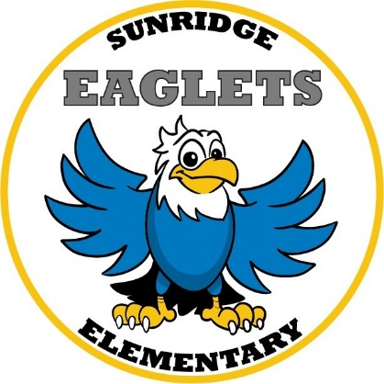

Kindergarten Supply List
2020 – 2021

- One 1 Inch Three Ring Binder with Clear View Pocket on Front
- 4 Boxes of Crayola Crayons-24 count
- 24 Elmer’s Glue Sticks (washable) (12 regular size and 12 jumbo)
- 2 Reams of Copy Paper (500 ct.)
- 12 Pre-Sharpened #2 Yellow Pencils
- 1 Pack Expo Low Odor Black Chisel Tip Dry Erase Markers (4 pk.)
- 1 Fiskar Kids Scissor (blunt)
- Headphones
- 1 Box Kleenex Tissue
- 1 Bottle Hand Sanitizer
- 1 Box Ziplock Gallon Bags (20 ct.)
- 1 Box Ziplock Sandwich Bags (50 ct.)
- 1 Pack Unscented Baby Wipes (100 ct.)
- 1 Container Lysol Disinfectant Wipes

Activity Fee $20 (Includes Class Shirt and In-house Field Trip)

The following items are also very helpful in the classroom, but are optional.
If you are able to send in any of these items we would greatly appreciate your help!

Band aids Index Cards (Ruled)
Lysol Spray Extra Hand Sanitizer
Liquid Soap

