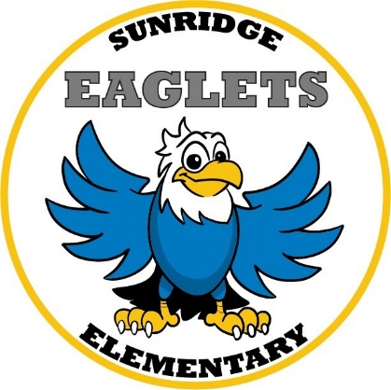

Fourth Grade Supply List
2020 – 2021

- 4 Spiral Notebooks (70 ct.)
- 2 Reams of Copy Paper
- 3 Dozen #2 Pencils (Pre-Sharpened)
- 8 Jumbo Glue Sticks (washable)
- 1 Pack Crayola Classic (8 ct.)
- 1 Pack Crayola Colored Pencils (12 ct.) or crayons
- 1 Pencil Box
- 10 Expo Dry Erase Markers
- 3 Box Kleenex Tissue
- 3 Assorted Colors Poly Pocket with Brad Folders
- 1 Fiskars Sharp Scissors (kids)
- 2 Pink Bevel Eraser (Latex Free)
- Headphones or Earbuds
- Clorox wipes or disinfectant
- 1 Classroom hand sanitizer
- 1 small personal hand sanitizer

Activity Fee $20 (Includes Class Shirt and In-house Field Trip)

The following items are also very helpful in the classroom, but they are optional. If you are able to send in any of these items we would greatly appreciate your help!

Band aids
Sandwich or gallon ziplock bags

