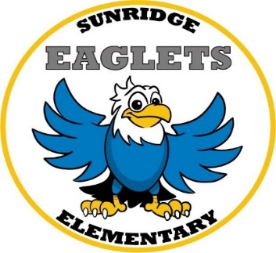
First Grade Supply List
2020 – 2021
- One 1 1/2 Inch Three Ring Binder with Clear View Pocket on Front and Pockets Inside
- 1 Mead Primary Journal (K-2 with top half blank and bottom half lined)
- 4 Boxes of Crayola Crayons (24 ct.)
- 1 Box Crayola Ultra Clean Wash Thick Markers (8 ct.)
- 2 Pink Bevel Eraser
- 1 Pack Expo Low Odor Black Chisel Tip Dry Erase Markers (4 pk.)
- 2 Dozen #2 Ticonderoga Pre-Sharpened Pencils
- 1 Plastic Pencil Box
- 1 Fiskar Scissors (Blunt)
- 24 Elmer’s Glue Sticks (washable)
- 2 Reams of Copy Paper (500 Ct.)
- 1 Box of Tissues
- 1 Container Lysol Disinfectant Wipes
- 1 Bottle of Hand Sanitizer
- 1 Bottle Liquid Soap
- Headphones (no earbuds)
- Reusable Water Bottle for filling station
- Masks are required

Activity Fee $20 (Includes Class Shirt and In-house Field Trip)

The following items are also very helpful in the classroom, but they are optional. If you are able to send in any of these items we would greatly appreciate your help!

Band aids Gallon Ziploc Bags
Baby Wipes Quartz Size Ziploc Bags
Lysol Spray Hand Sanitizer
Liquid Soap Plastic Sheet Protectors (10 ct.)

