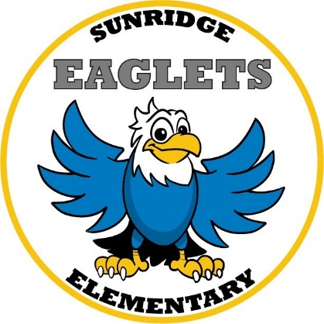

Fifth Grade Supply List
2020 – 2021

- One 1 ½ Inch Three Ring Binder
- 2 Packs of Wide Ruled Notebook Paper (100 ct.)
- 2 Reams of Copy Paper
- 1 Pencil Box
- 1 Pencil Sharpener (small with cover)
- 1 Box Crayola Crayons (24ct.)
- 1 Box Crayola Classic Thick Markers (8 ct.)
- 1 Box Crayola 7” Colored Pre-sharpened Pencils (24 ct.)
- 1 Pack of Clear Sheet Protectors (10 ct.)
- 2-3 Boxes of Pencils (#2 pre-sharpened if possible)
- 1-2 Packs of Expo Low Odor Dry Erase Markers (6 total)
- 5 Spiral Notebooks (120 Sheet count preferred)
- 2 Pocket Only Folders
- 4 Jumbo Glue Sticks (washable)
- 4 Yellow Highlighters
- 1 Pair of Fiskar Pointed Scissors
- 1 Pack Assorted Construction Paper (50 ct.)
- 1 Set of Computer Earbuds/Headphones
- 2 containers of Clorox wipes
- 2 bottles of Hand Sanitizer
- 2 boxes Kleenex Tissue
- Quartz Size Ziploc Bags
- Gallon Size Ziploc Bags

